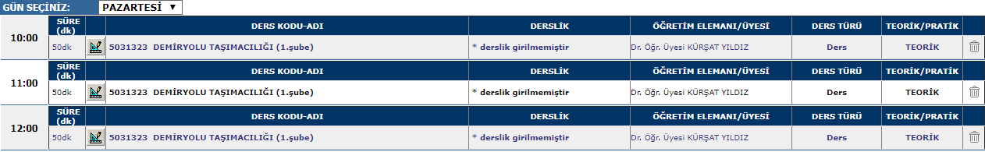
19:30
17:30
18:30


