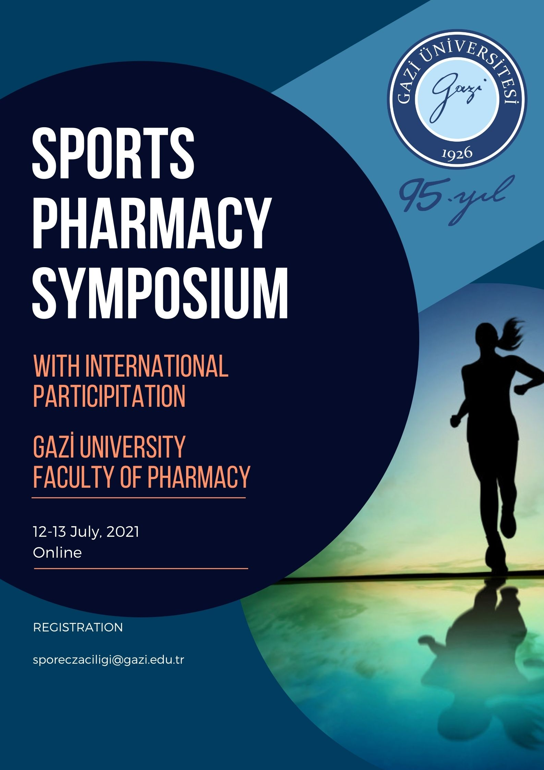
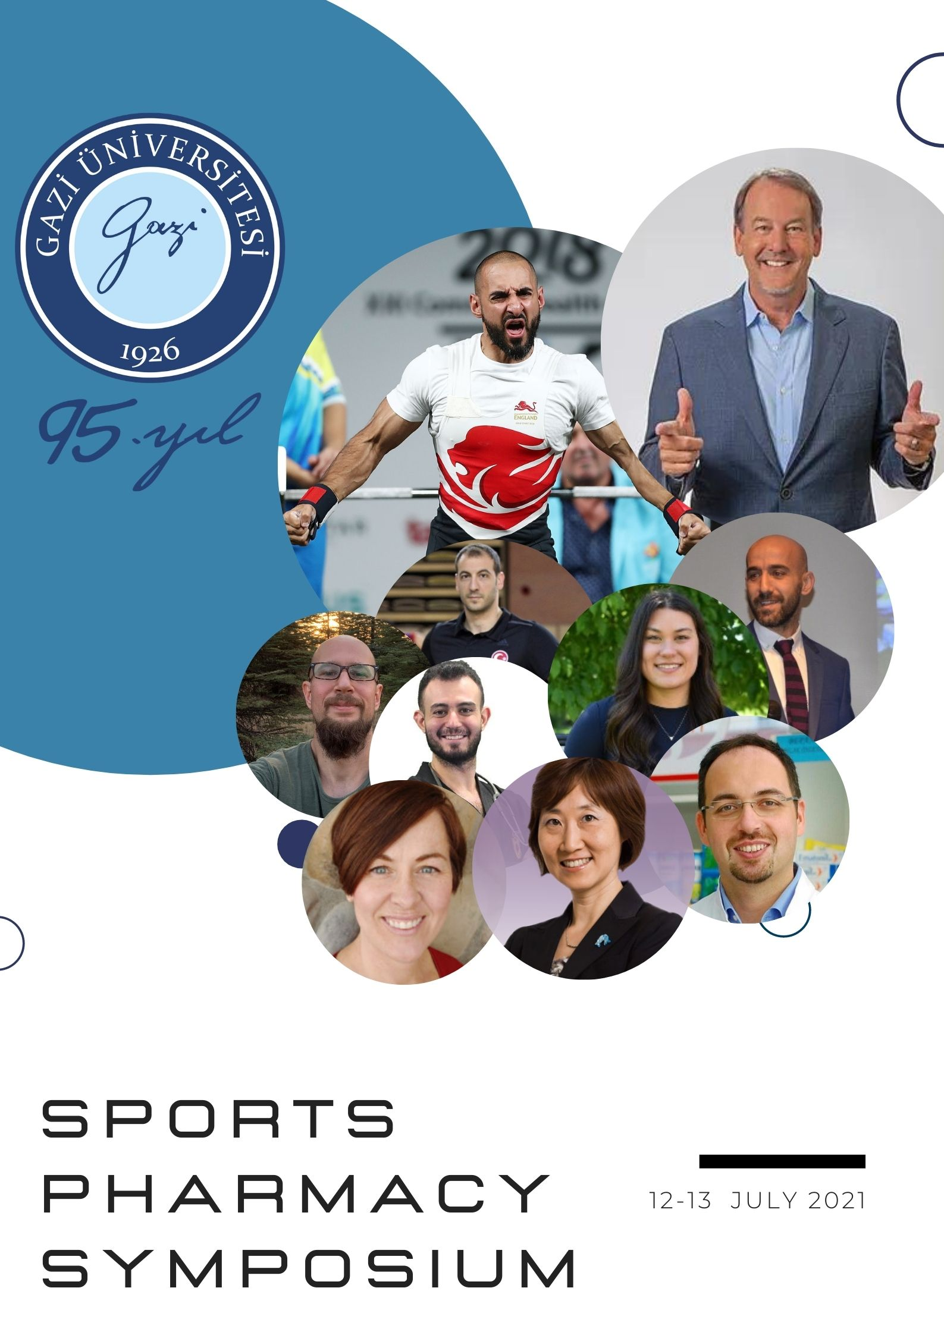

Dear Pharmacists;

The 1st Sports Pharmacy Symposium organized by Gazi University Faculty of Pharmacy will be held on 12-13 July 2021 with international participation. Sports Pharmacy is an innovative field of specialization have developing worldwide in connection with the health, economic and social sectors. Providing the most effective and most accurate information for better performance and athlete health in every field where participation in sports and exercise by pharmacist is important on professional and non-professional levels.

In our symposium, we aim to bring together important lecturers in this field from national and the worldwide and contribute to the development of pharmacy. Our symposium will be held online. We will be honored by your participation in the Gazi University Sports Pharmacy Symposium.

Our symposium is free. The number of participants is limited. Please fill out the form and send it to sporeczaciligi@gazi.edu.tr for registration. The full program will be announced in the coming days after registration. Hope to see you in Symposium.

REGISTRATION FORM
Please fill out the form and return by Email to: [sporeczaciligi@gazi.edu.tr]
Registrant Information
First Name
Last Name
Graduation Year |  | Faculty
Email
Designation/Position
Company/Org.
Address: | [City] [State][Zip]

